Phillip E M Leith Memorial Volunteer Award

Nomination Form

Confidential when completed

UELAC Vancouver Branch

Phillip E. M. Leith UE Memorial Award

 | Candidate |  |  |  |  | Nominator
 | Mr. / Mrs. / Ms. |  |  |  |  | Mr. / Mrs. / Ms.
 | Full Name |  |  |  |  | Name
 | Home Address |  |  |  |  | Title
 | Postal Code | Canada |  |  |  | Address
 | Telephone |  |  |  |  | Telephone
 | Cell |  |  |  |  | Cell
 | Branch: |  |  |  |  | Branch:
 | Membership |  |  |  |  | Signature:
 | Loyalist Ancestor (s):
 | Where Settled & Date: |  |  |  |  | Date:

Please provide the following information on a separate page or in a covering letter.

- The reasons why this individual is being nominated
- An up-to-date biographical sketch of the nominee including

  - UE Branch activities with responsibilities and time frames o dates of specific deeds or activities

o dates of active participation within the local UE Branch, or Region o all official honours / awards

- Any other information that might assist the independent committee that recommends recipients to the Governor General

References – Persons who might support this nomination

Persons who might support this nomination should be familiar with the nominee's achievements, e.g., officials of organizations in which the nominee is or has been an active member. To maintain confidentiality, it is preferable these persons not be contacted by the nominator.

1 | Mr. / Mrs. / Ms. | 2 | Mr. / Mrs. / Ms. | 3 | Mr. / Mrs. / Ms.
 | Name |  | Name |  | Name
 | Address |  | Address |  | Address
 | Postal Code |  | Postal Code |  | Postal Code
 | Telephone |  | Telephone |  | Telephone

Please send the completed form and attachments to:

Mr. Carl Stymiest UE

Chairperson: Phillip Leith Memorial Award
331 Leroy Street

Coquitlam, British Columbia
Canada V3K 5K5

cstymiest@gmail.com
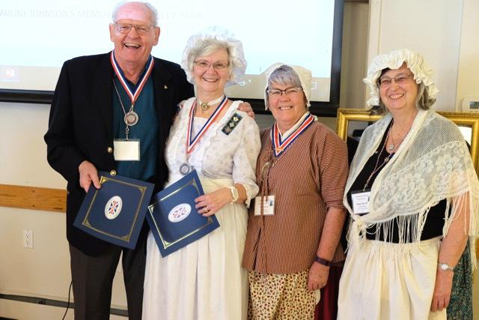

Page 2 of 2

